
Company
Logotype

Cone Beam Computed Tomography- Report



Porur Dental X-rays & CBCT

Patient Name : Mr. Krishnamurthy | Date of Report : 04.06.2024
Age/ Gender : 51 years/ Male | Region of Interest : CBCT Sectional Mandible
Referring doctor: Dr. A. Dany | Indication : Implant assessment
Clinical Notes: Nil
PATIENT INFORMATION

CBCT- Sectional Mandible provided
CBCT – IMAGE DETAILS

RADIOGRAPHIC INTERPRETATION

- In relation to 33, 34, 35, 36, presence of hyperdense crown structures evident.
- In relation to 37, presence of restorative material in relation to the pulp canal extending upto the apical third of the roots is evident.
- In 36 region, presence of hyperdense screw like structure suggestive of dental implant. The alveolar bone around the implant is present with resorptive changes and evidence of a hypodensity around the implant is noticed.
- The alveolar bone in relation to 34, 35 region is present with normal trabecular pattern.

IMPLANT ASSESSMENT

 | 34 region | 35 region
Sub-Crestal (in mm) | 4.23 | 5.03
Mid- Crestal (in mm) | 6.04 | 7.85
Distance between alveolar ridge and the inferior alveolar nerve canal (in mm) | - | 8.86
Distance between alveolar ridge and the inferior border of mandible (in mm) | 23.73 | 20.37

RADIOGRAPHIC IMPRESSION

- Implant assessment done in relation to 34, 35 region.
- Peri- implantitis in relation to 36 implant.
- Root canal treated: 37

Kindly correlate with clinical findings


IMAGES FOR REFERENCE

RECONSTRUCTED PANORAMIC VIEW

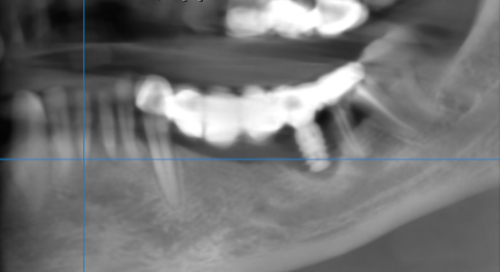

3-DIMENSIONAL VIEW

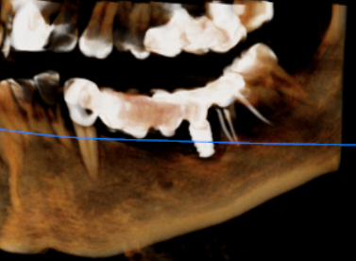

CROSS SECTIONAL VIEW

34 region | 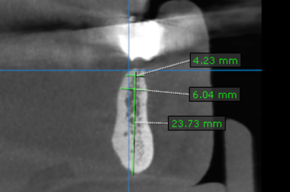
35 region | 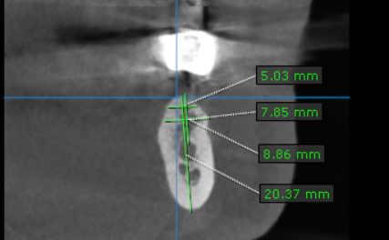
36 region | 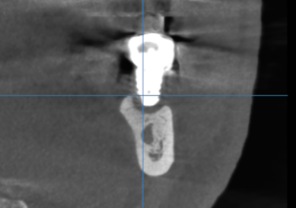

**** End of report ****

